2026 MLTSS Leadership Summit Social Media Toolkit
This toolkit provides ready-to-use posts, graphics, and best practices to help you share your participation in this year’s MLTSS Leadership Summit.
Whether you’re joining as an attendee, speaker, or sponsor, these resources make it easy to highlight your involvement, celebrate your impact, and amplify key conversations across LinkedIn and other platforms. Feel free to personalize the sample messages to reflect your organization’s voice and audience.

Best Practices
- Tag us on LinkedIn: @National MLTSS Health Plan Association
- Tag co-presenters, partners, or organizations featured in your session
- Highlight your participation in the 2026 MLTSS Summit using the following hashtag:
  - #MLTSSSummit2026
- Add photos or graphics from our official social media kit
- Encourage engagement — ask a question or invite others to meet at the summit.

Attendees
Example LinkedIn post
I am excited to attend the 2026 MLTSS Leadership Summit, hosted by the @National MLTSS Health Plan Association!
The Summit invites leaders focused on Managed LTSS and integrated care to share ideas, discuss emerging priorities, and explore new approaches to improving services for older adults and individuals with disabilities.
I’m looking forward to learning from fellow attendees, connecting with colleagues, and being part of the conversation shaping the future of MLTSS and Integrated Care.
If you’ll be at the Summit too, let’s connect!
#MLTSSSummit2026
Attendees
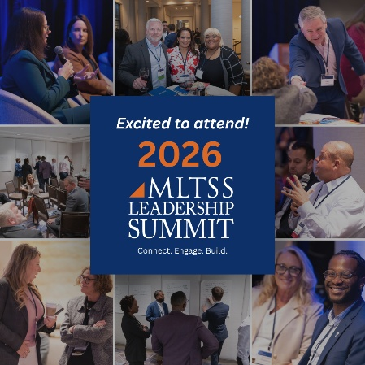  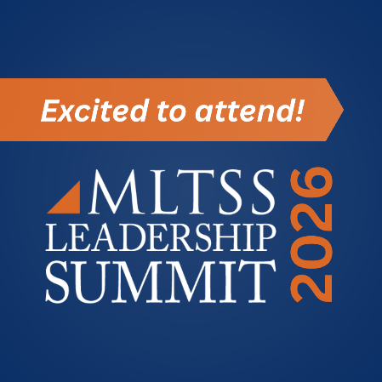 | 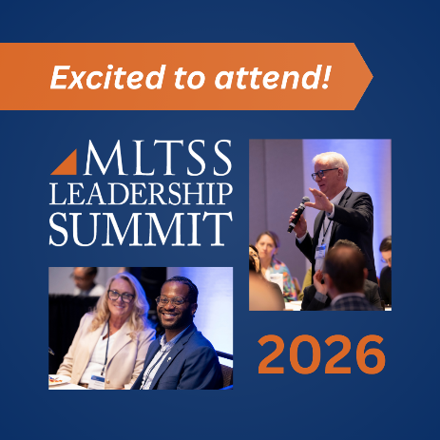  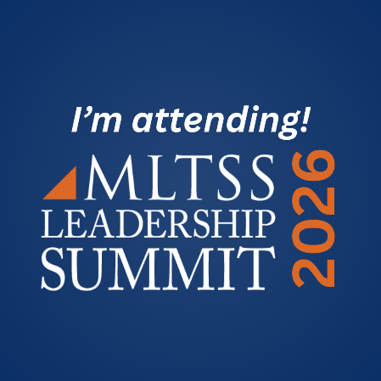 | 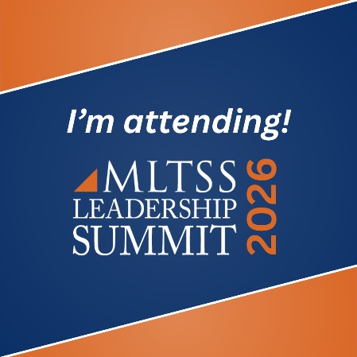  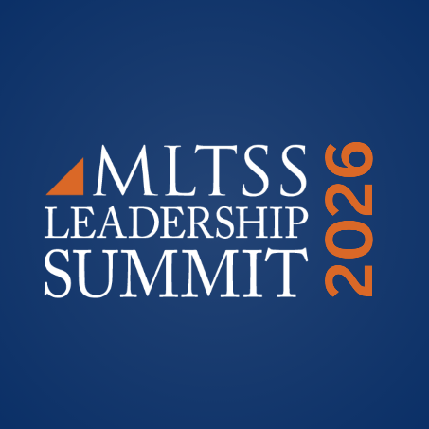

Speakers
Example LinkedIn Post
I am excited to join the 2026 MLTSS Leadership Summit as a speaker, hosted by the @National MLTSS Health Plan Association!
I’ll be participating in the [Insert Session Title] session, where we’ll explore [Insert topic/short description] and share perspectives on the opportunities and challenges shaping the future of MLTSS and Integrated Care.
I’m looking forward to connecting with fellow leaders, exchanging ideas, and contributing to the conversations happening across the LTSS community.
#MLTSSSummit2026
Graphics
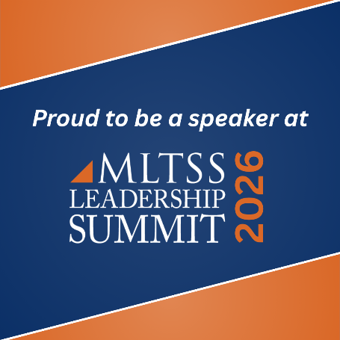 | 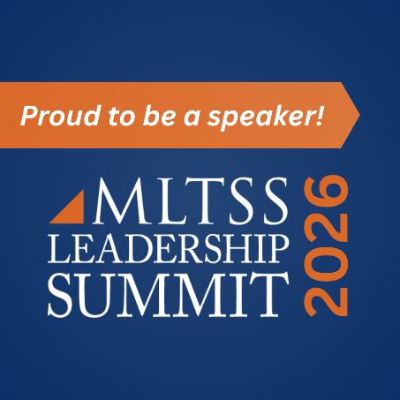  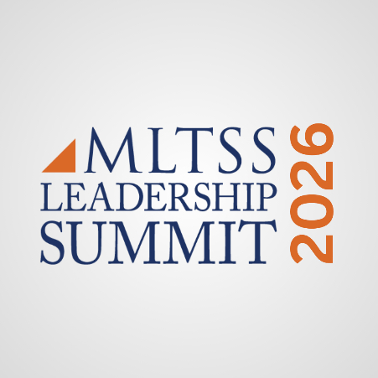 | 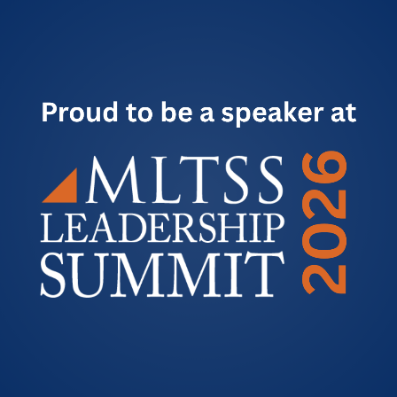

Sponsors
Example LinkedIn Post
We are proud to support the 2026 MLTSS Leadership Summit, hosted by the @National MLTSS Health Plan Association!

The Summit invites health plans, policymakers, providers, and other leaders from across the country to exchange ideas and advance conversations around the future of MLTSS and Integrated Care.

At [Your Organization Name], we’re excited to be part of this collaborative forum and support efforts to improve care, services, and outcomes for older adults and individuals with disabilities.

We look forward to connecting with leaders and colleagues at the Summit!

#MLTSSSummit2026
Graphics
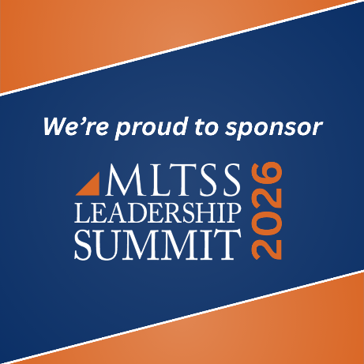 | 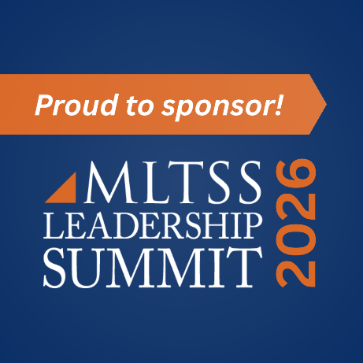 | 